
Company
Logotype

Cone Beam Computed Tomography- Report



Porur Dental X-rays & CBCT

Patient Name : Mr. Venumadhav | Date of Report : 21.08.2024
Age/ Gender : 32 years/ Male | Region of Interest : CBCT Sectional Maxilla
Referring doctor: Dr. Lakshmi | Indication : Periapical pathology in relation to 26
Clinical Notes: Nil
PATIENT INFORMATION

CBCT- Sectional Maxilla provided
CBCT – IMAGE DETAILS

RADIOGRAPHIC INTERPRETATION

- The tooth 26 is present with hyperdense restorative material involving the pulp canal extending upto the apical third of the roots.
- Presence of hypodense area evident in the periapical region of mesial and palatal root of 26 in relation to the palatal root measuring 10.73 x 13.42 x 11.8 mm in dimension with well-defined sclerotic borders.
- The left maxillary sinus is present with mucosal thickening in relation to the floor of the sinus.

RADIOGRAPHIC IMPRESSION

- Periapical pathology in root canal treated tooth: 26
- Left maxillary sinusitis.

Kindly correlate with clinical findings


IMAGES FOR REFERENCE

RECONSTRUCTED PANORAMIC VIEW

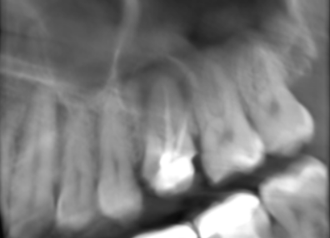

3-DIMENSIONAL VIEW

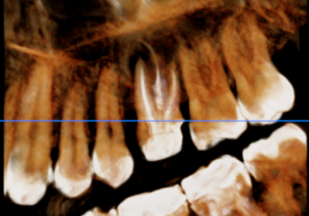

CROSS SECTIONAL VIEW
26 region

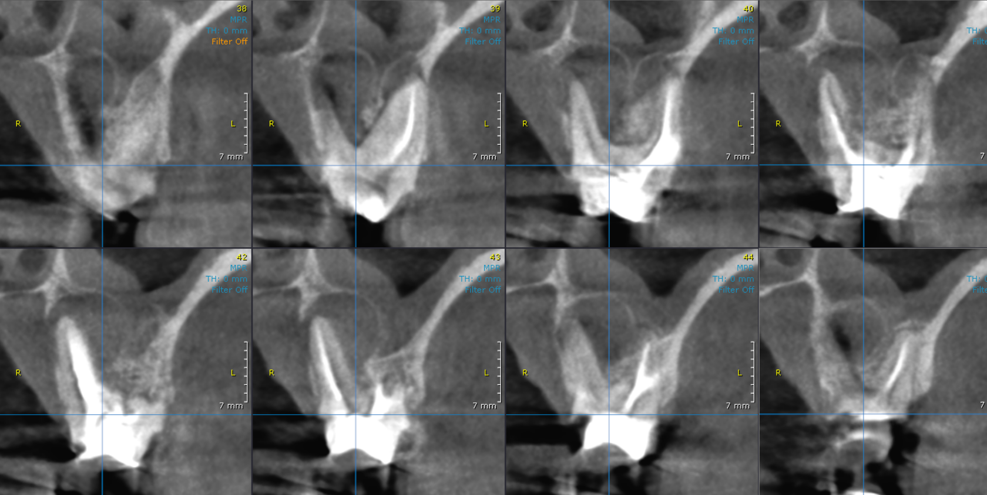

**** End of report ****

